- Conceptual art, sometimes called Conceptualism, is art in which the concept or idea involved in the work takes priority over a type of traditional philosophy and material concerns.
- Conceptual photography is a type of photography that illustrates an idea
- 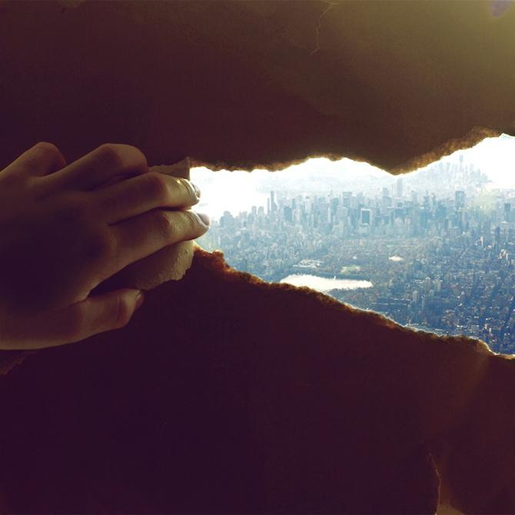Someone ripping thru paper and seeing the world
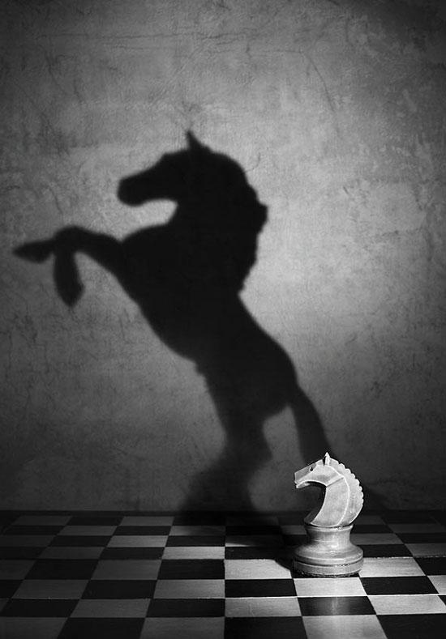a horse that has no legs has a shadow that appers to make out the horse with legs and it standing up.
someone in space with lights lighting them up.

